Rotary Club of Wingham (Inc) PO Box 57
Wingham
NSW 2429
RYAG Dairy
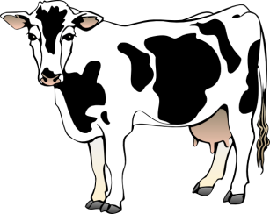2018
Aim : To provide year 9/10/11 students with a unique insight into the Dairy Industry.
The camp involves hands on milking at recognized dairies, artificial insemination and practical dairy industry activities. Guest speakers will talk on pastures, veterinary services and other related matters. Students in groups will be trained in caring for and grooming of heifers to a show standard.
Prominent professional people involved in the dairy industry are the organizers of the farm activities. Rotarians are responsible for catering, transport and supervision. Plenty of time has been allocated for fun.
Date : From 11am Sunday the 7th October to 2pm Wednesday 10th October 2018.
Location : Students will be housed in facilities at Wingham Showground under supervision of Rotarians in attendance throughout the camp.
Cost: The cost will be $200 each and cover all meals and accommodation plus all tuition and associated course documents. Students are expected to contribute to the costs and seek support or sponsorship from their local Rotary Club for the balance. The cost of and arrangements for travel to and from the course is the responsibility of the students.
Program: Schools will be notified of the camp during August. Rotary Clubs are requested to contact their local high schools and leave this information with the appropriate teacher as soon as possible to encourage student interest. Please note that the camp is limited to 20 participants in order as receipted and forms and cheques should be sent to the above address.
Enquiries : Allan Brown phone 02 6553 5813 or email winghamryagdairy@gmail.com

