 Rotary Club of Wingham (Inc) PO Box 57
Wingham
NSW 2429
RYAG Dairy
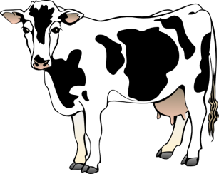2018
Dear Principal
This letter is to advise that the Wingham Rotary Club will again be holding the RYAG Dairy Camp for year nine, ten and eleven students who are interested in learning about the Dairy industry and associated rural occupations.
The camp will be held at the Wingham Showground facilities during the school holidays commencing at 11am on Sunday the 7th October and concluding at 2pm on Wednesday the 10th October 2018. The number of students able to attend will be restricted to twenty and applicants will be accepted on the basis of first in. Preference will however be given to those who have not attended previously. Transport to and from the camp will be the student’s responsibility.
The program will be similar to previous camps and will cover facets of the Dairy Industry, including hands on milking at selected dairies, artificial insemination, agronomy, veterinary services, calf rearing and recreation. Students will also be taught basic calf handling and preparation for show presentation so will be required to work under supervision with cattle.
Cost of the camp is $200 however some financial support may be available from your local Rotary Club and you should contact them direct to ascertain the level of support they are prepared to offer.
Should the school not have been contacted by a member of your local Rotary Club to make registration of intending applicants, students wanting to attend should contact the email address below as soon as possible. The closing date for applications will be when the number of applications reaches 20.
Thank you in anticipation for bringing this notice to the relevant teacher to inform interested students to ensure success of the camp.
Allan Brown
Wingham Rotary Club
Phone 02 6553 5813
Email winghamryagdairy@gmail.com

