Registration Form: Presidents-elect Training
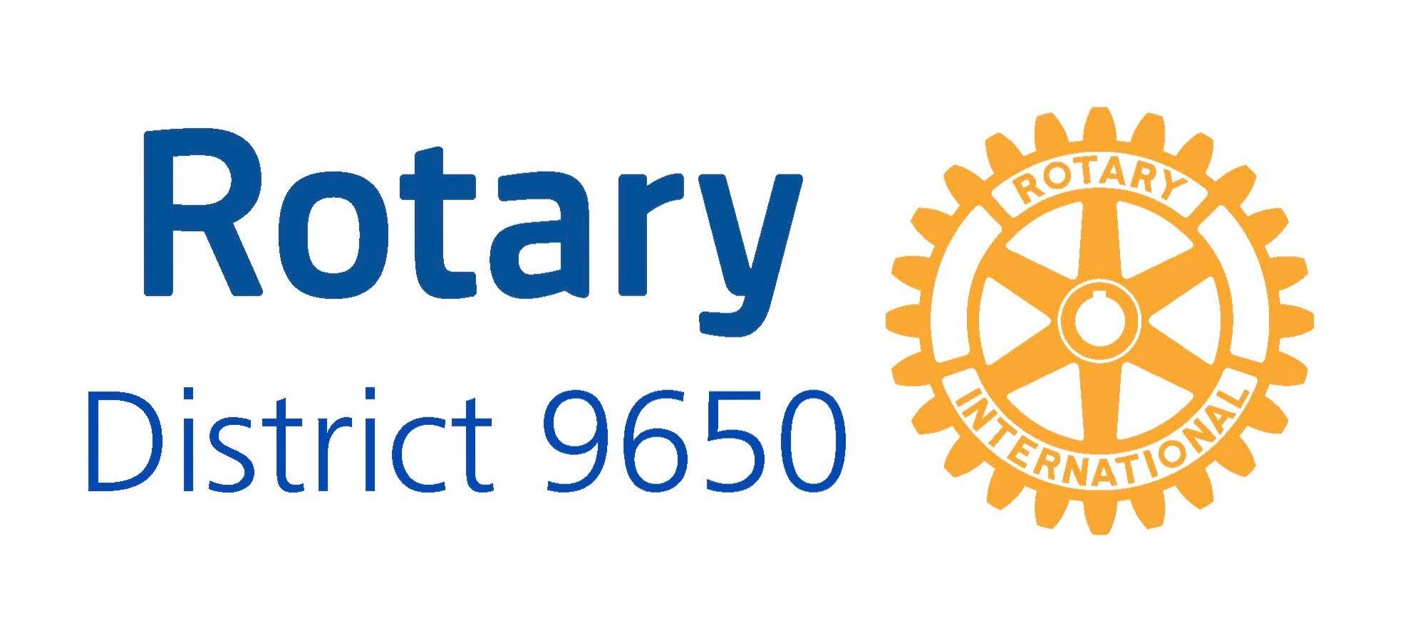

Date | Venue | Please tick venue attending
Sunday 7 March 2021 | Armidale City Bowling Club, Armidale
Sunday 21 March 2021 | Charles Sturt University, Port Macquarie

ATTENDEE:
Name: |  | Email:
Contact Tel: |  | Role if delegate if not President-elect:
Rotary Club:

$40 per head | $40.00
Note please list any special diet needs at foot of page.

Please return this form to current District Secretary Patti Parsons prior to 5pm the preceding Sunday to the actual meeting (District Secretary 2020-2021 via email to patti.mach@bigpond.com ) . Note for Armidale that is by 5pm Sunday 28 February 2021 & for Port Macquarie 5pm Sunday 14 March 2021.
Preferred payment method is via Direct Credit to the following Rotary International D9650 Account:

Name: Rotary International District 9650 Training | BSB: 932-000 | Account No. 500195726 | Reference: “YourSurname.PETS21”
Alternatively, payment can be made on arrival at the Training session by cheque. If by cheque, then make cheque payable to “Rotary international District 9650 Training”
Note: The cost for the session includes the cost of morning & afternoon tea as well as lunch, facility hire and a contribution to Training expenses.
It is recommended that each Club pay for their President-elect and partners attendance at PETS as this is a cost that the Club should meet.
Please advise below any special dietary requirements:

